The Gratitude Gallery: Photography sessions
Wednesdays 10.30am to 12.30pm
7th July - 4th Aug at Looking Well, Bentham
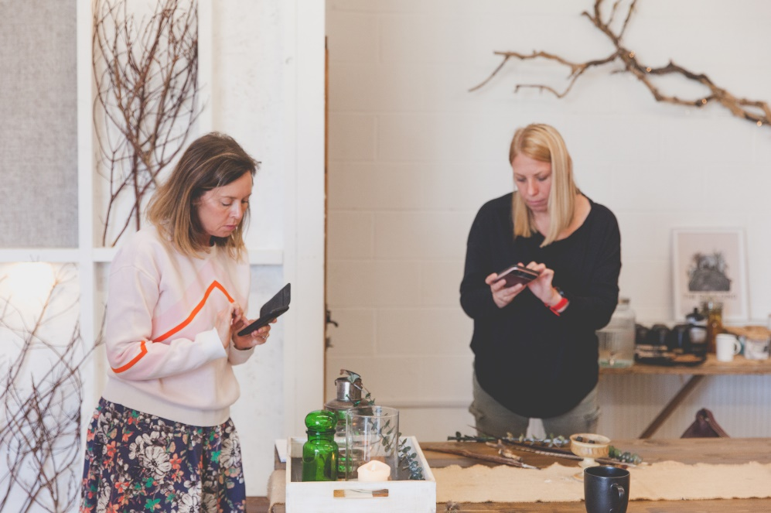
A smartphone photography session, designed as a mood-boosting creative group activity.
Gratitude is a powerful practice that encourages us to switch our awareness to what we have, rather than focusing on the things we feel we lack. This is an interactive and fun course and a fantastic opportunity to meet new people.
The course comprises 5 sessions, where you'll learn phone photography and editing skills and use these to notice and record the aspects of your daily life that you feel grateful for.
At the end of the course, we will also create an online gallery of your images to share more widely representing your moments of appreciation, experienced and captured.
For more information or to book a place:
email office@pioneerprojects.org.uk or call 015242 62672

