**Raising essential funds for your local sight loss charity, supporting people living with sight loss across the South Lakes area.**

**AUTUMN CEILIDH & Light Supper**

[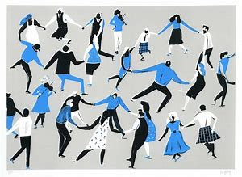](https://www.bing.com/images/search?view=detailV2&ccid=8R2Pq9GX&id=5B6C10BE809AB5B1F3F0305ABAC854C4EDE71253&thid=OIP.8R2Pq9GXOF6FXtQlH_ZWlgHaFk&mediaurl=https%3a%2f%2fcdn.shopify.com%2fs%2ffiles%2f1%2f0817%2f1837%2fproducts%2fLUCY-BANAJI_CeilidhScan_FULL_V2.jpg%3fv%3d1502096055&exph=1540&expw=2048&q=ceilidh&simid=608055037621437156&selectedIndex=106)

**Date: Sat 9th November 2019**

**Time: 7.30pm - 10.30pm**

**Venue: Castle Street Community Centre,**

**Castle Street, Kendal, LA9 7AD**

# **Tickets: £10.00pp - Live Music by ‘Jackodandy’ & light supper. Soft drinks available or bring own bottle**

**Tickets Available:**

**Sight Advice South Lakes 116 Highgate Kendal. LA9 4HE. Tel 01539 769055**