February 2021 Newsletter

Energy Top Up Vouchers
Thank you for all your referrals.
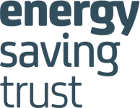
Since 30th October we have issued 549 vouchers to households across North Yorkshire. The funding was for 600 vouchers to be issued so we will have achieved our target by the end of this month. Please can you signpost / refer clients to NYCC Local assistance Fund and if they are unable to help don’t hesitate to contact us. We will update you of alternative sources of support they become available.
Energy Advisers
Through the Energy Redress Funding Glen and Maciej our Energy Advisers have supported an additional 75 households since December with energy switching, energy efficiency advice and liaising with energy suppliers regarding large energy bills and Warm Home discount applications.

Energy Cap 01.04.21
Ofgem have announced that the energy price cap will raise on the 1st April by £96 from £1,042 to £1,138 for customers with a credit meter. For customers paying by pre-payment meter, the level will rise by £87 from £1,070 to £1,156.
Through the cap, Ofgem makes sure that any price rises are justified against the estimated costs to supply electricity and gas for suppliers in a six-month period. Suppliers can’t charge anything above the cap
Around 15 million households, including 4 million prepayment meter customers are on a default tariff and covered by the cap, to avoid this increase Warm and Well partnership can support clients to switch from the standard / default tariff. If you are working with anyone who you feel would potentially could be in this group of customers please refer to Warm and Well 01609 7676555 or complete an online referral www.warmandwell.org.uk

Citizens Advice Mid-North Yorkshire
Money& Benefits North Yorkshire 0300 3031 598
Free advice on Universal Credit, welfare benefits or help managing money. We're open 9-4pm Mon-Fri - if we can't answer, there's a voicemail facility to leave a message. You can also leave a message outside of our opening hours and we'll get back to you.
Extra Legal Help for North Yorkshire Residents
A new project, set up by Citizens Advice in North Yorkshire, is giving legal help and advice to those who need it to solve problems in their everyday lives, as well as support for those representing themselves in court. Three newly recruited legal advisers are already helping clients with issues around, housing, family and discrimination.
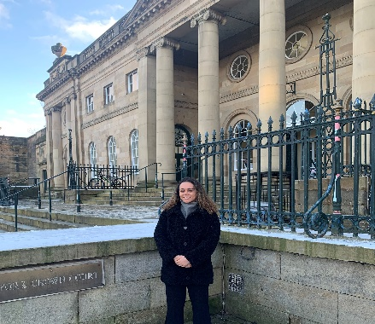
The aim of the project is to prevent people having to go to court by giving early legal advice and guidance to those worried about their situation. Those who do need to go to court can get help in understanding their rights and in preparing for the day; and for clients in special need, a legal adviser can be found to represent them in court.
Contact: Adviceline ️ 0808 278 7900 (Freephone), Office 01757 701320, email address via www.citizensadvicehrs.org.uk

Online 3rd party referrals
Mid -North Yorkshire Citizens Advice can now accept online 3rd party organisations referrals. e.g. local authorities to make referrals to us. Whenever possible, clients must still be encouraged to contact CA themselves, but if this is genuinely not possible, external organisations can make a referral via our website. https://citizensadvicehrs.org.uk/get-advice-contact/

Partnership Update

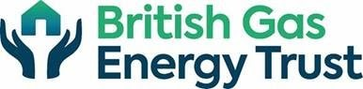
British Gas Energy Trust
January and February have been busy months for the British Gas Energy Trust delivery partners. Even the return of the Covid-19 lockdown didn’t stop us. There has been a steady stream of individuals requiring support with their energy bills, energy efficiency measures and debts.
The current cold snap has given a sense of urgency to the households we are seeing with broken heating or no money to top up their meters. With the project providing seven oil filled radiators in the last two weeks and continuing to offer vouchers through the online shop.
The project is due to finish at the end of March 2021 and our main aim is to use our remaining funding to help as many households as we can, providing them with advice, repairs, measures and emergency help.
If you know anyone who would benefit from this funding please refer them into the Warm & Well in North Yorkshire helpline.

Yorkshire Energy Doctor
Help us to promote the Priority Services Register
The Priority Services Register is a free service which gives households extra help from their energy supplier, or support if there was a powercut or an interruption to their gas supply. Eligible households include those who have a child under 5 or someone who is of pensionable age, disabled, has a long-term medical condition, is dependent on electricity for medical reasons, or has a hearing or visual impairment. If you would like any flyers posted to you to promote this or information for social media/your own newsletters then please just get in touch - kate@yorkshireenergydoctor.org.uk
Free training opportunity - Become a Community Energy Ambassador
Join 77 other organisations from across the north of England who have already taken the positive step to have one or more of their staff or volunteers trained as a Community Energy Ambassador. Our enjoyable and informative course will give you the skills and knowledge you need to be able to help vulnerable households reduce their energy costs and be warm, safe and well at home. The course runs over 3 sessions and the next one starts on Thursday 4th March, 10-11.30am. You can find out more information and book your place here: http://bit.ly/energyambassadors10
Any questions then please contact Kate: kate@yorkshireenergydoctor.org.uk or 07738 818391
Green Doctor 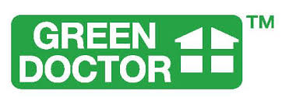
Green Doctor in partnership with Warm and Well, deliver energy assistance across North Yorkshire. They currently have funding until June 21 to issue Fuel Vouchers.

Support available from the Warm and Well partnership
- Energy comparison and switching
- Applications for Energy Trust Funding and Grants.
- Practical advice on energy efficiency measures
- Referrals to partners to conduct home visits for Heating and
insulation advice and installation.
- Energy Debt Advice
- Applications for funding for the purchase of emergency fuel i.e. coal,
electric heaters, prepayment cards and Gas bottles from various
charitable organisations.
- Support clients with high energy bills.
- Sourcing funding for New or replacement boilers and heating systems
and installation.

Open Invitation
It you would like any further advice on how Warm & Well can support either you or your clients do not hesitate to contact the team on 01609 767555

Thank you for all your support and look forward to hearing from you.

Julia, Susan, Holly, Karolina, Glen & Maciej
Warm & Well in North Yorkshire

