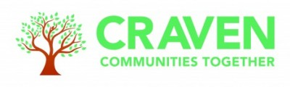

Notes from Craven Communities Together Wider Forum
Dementia Support in Craven
Wednesday, 17th January , 10am – 12 noon
Microsoft Teams

1) Welcome and introductions
Dena welcomed all to the meeting which focuses on Dementia Services and invited attendees to introduce themselves in the chat.

2) General Update from Co-ordinators Group
Dena gave a brief update on subjects discussed at January Co-ordinators Group.
The key topic of discussion was funding, Craven is one of 13 Community partnerships across Bradford & Craven, next year budgets will be tighter and there will only be funding for small grants and infrastructure costs of running the partnership.

There is some surplus funding from the current year and proposals for how this will be allocated will be circulated to the wider partnership for feedback.

3) Dementia Awareness
Claire Burke from Dementia Forward gave a presentation giving the history of Dementia Forward and an overview of its current services and community initiatives in Skipton and Settle to support people living with dementia.

Copy of the presentation available on Compass Craven

4) Young Onset Dementia Services
Karen Thomas from Dementia Forward spoke about their bespoke Young Onset Service. Service is for people who are younger than 65 when initially experiencing symptoms. Youngest person they have supported was 37 generally people are in their 50s and early 60s. can take along time for diagnosis as often misdiagnosed as not expecting symptoms to relate to dementia at a younger age.

Young onset hits people when they have busy lives, still at work, with children at home, not pension age, partner and friends still working, may still be paying mortgage, may be caring for parents, so can be difficult financially and no one at home to help with care.

Aim to keep people living well and support them to carry on doing the things they want to.

Try to provide a service with people of a similar age so they can meet with peers who they have things in common with.

Currently have 31 clients with early onset dementia in Craven.

Have a lottery funded groups called Time Out Together which involved wellbeing days out in the community, activities such as walks, art galleries, climbing, cinema as people often still very physically fit and active, will be starting a Craven Time Out Together group in February.

Also developing an early onset hub in North Yorkshire but needs to be appropriate for the people needing the service. Social activities examples include working with York Climbing Wall to support users with dementia, training museum staff and raising awareness. Identifying volunteering opportunities so that people with dementia can still contribute and work.

Young Onset Dementia, Dementia Forward, North Yorkshire's leading dementia charity

In order to raise awareness of early onset dementia have set up U&Me Campaign as nationally need for services is not recognised.

Campaign Objectives are to Raise awareness, and keep people living with young onset dementia doing what they love for as long as possible and to deliver a pioneering, specialist, age appropriate care and support model for Yorkshire.
U&ME Campaign, Dementia Forward, North Yorkshire's leading dementia charity

Dementia Forward Helpline for all services is 03300 578592

5) Bentham Dementia Partnership
Jonathan Scott Manager of Bentham Medical Practice gave an update about Bentham and District Dementia Friendly Community.

Started in 2017 raised dementia awareness through Bentham, Ingleton and surrounding area but didn’t have strong links to people with dementia.

Set up a breakfast club at Bentham Fire Station, with support from Craig Lyons which has grown over the years regularly get 20-25 people. Supported by North Craven Age UK and Looking Well and run a wide variety of activities and outings.

Plan for this year is a trip to Newby Bridge and hiring a steamer on Windermere.

Would like to link with Dementia Forward and other services to make sure service is sustainable into the future.

Bentham been very active supporting dementia awareness and also had a dementia friendly train line.

6) Pioneer Projects Dementia Services
Leon Fijalkowski from Pioneer Projects talked about their dementia support services.
Pioneer Projects are a creative arts organisation and deliver services across Craven, aware that they are not reaching everyone who has dementia, important that everyone share information about available services and share through Craven Compass.

All services have an element of creative arts and are inclusive activities for people living with dementia and their carers.

Work with a range of partner organisations to link up services and make sure people are getting all the support they need. Can access all services via compass and also refer to other services.
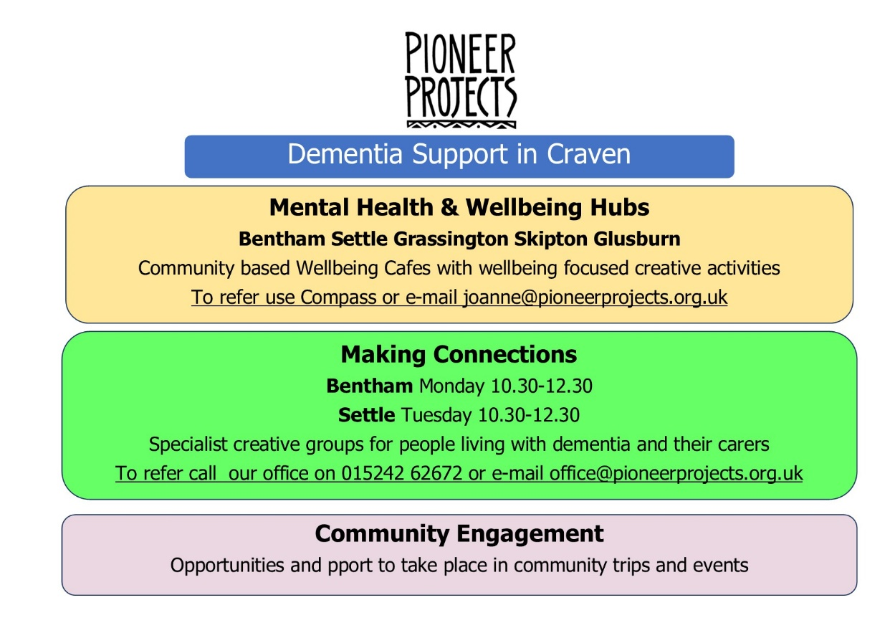
7) Memory Clinic Services
Janet McGuinness introduced Sarah Emmott from the Community Mental Health Team who gave a presentation about the Memory Clinic Services and the referral process.

Copy of the presentation available on Compass Craven

Carol through Carer Resource asked about re-assessment.
Janet confirmed that like reassessments should be carried out by a GP if people have been discharged from the Memory Clinic.

Louise from The Place asked whether people receive follow up calls after they have been discharges from the service. Janet fed back that people did not receive follow up calls but could recontact the service or speak to their GP.
Carers Resource will provide checkup calls but require consent in order to be referred across to Carers Resource.

Claire from Dementia Forward also agreed to meet with Sarah to see how the services could work together more closely.

8) Bring Me Sunshine North Yorkshire Dementia Strategy
Carly Walker from North Yorkshire Council gave a presentation about the refresh of the North Yorkshire Dementia Strategy.

Copy of the presentation available on Compass Craven

9) Key Issues for Future Discussion
Dena asked everyone to feedback ideas for themes for future meetings to Kate.

10) Upcoming Meetings and Events

11) AOB & Partner Updates
North Yorkshire Autism Strategy is currently out for consultation and event at Skipton Town Hall on 4 March. Autism strategy consultation | North Yorkshire Council

Joint Local Health and Wellbeing Strategy also out for consultation Joint Local Health and Wellbeing Strategy consultation | North Yorkshire Council

Craven Health Connectors jobs now open for applications
CCT Small Grant Scheme deadline 31 January
Carers Resource starting new group at Skipton Library 1st Thursday of the month.

12) Dates & Agenda for future meetings
21 February - Secondary Care & Support including Digital Services
20 March - Children & Young People

