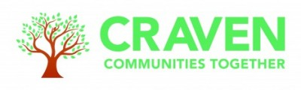

Agenda
Craven Communities Together Wider Forum
Winter Pressures
Wednesday, 20th September, 2-4pm
Microsoft Teams

Item No | Item | Presented by | Time
1 | Welcome and Introductions | Sharon Hudson | 5 mins
2 | Update of new roles within Craven Communities Together (CCT) | Sharon Hudson  Gemma Smith  Kate Senior | 5 mins
3 | Governance Update  Action – Establish a Governance Task & Finish Group | Sharon Hudson  Gemma Smith | 10 mins
4 | Financial Update  Action - Establish a ABCD Grants Task & Finish Group | Sharon Hudson  Gemma Smith | 10 mins
5 | Core 20 Plus 5 Update  Action – Endorse proposed Employing Organisations | Sharon Hudson | 10 mins
6 | Heating for Health | Kate Urwin | 15 mins
7 | North Yorkshire Warm and Well | Mark Boyer | 15 mins
8 | Household Support Fund & Local Assistance Fund | Adele Wilson-Hope | 10 mins
9 | Flu Immunisation Community Pop-Ups | Kate Senior | 5 mins
10 | Dentistry Working Group | Jonathan Kerr | 5 mins
11 | AOB  Skipton Non-surgical Cancer Care Engagement Event 27 September  Craven Disability Forum Survey Results  Wellbeing Network & Proposed Workshop  Self Care Week 13-19 November | All | 15 mins
12 | Dates & Agenda for future meetings  10 October 10am - Food, Health &Wellbeing  15 November 10am  20 December 10am | All | 5 mins

