
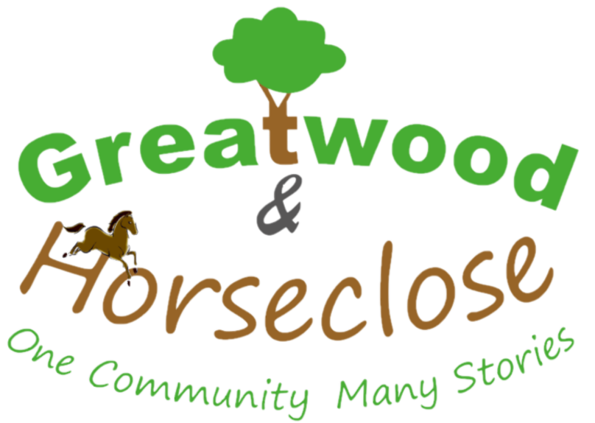

New Volunteer Opportunity

Role:
Estate Echo Editor

This role involves:
Coordinating content for the newsletter which goes out 3 times a year

Maintaining contact with regular contributors and locating new ones

Collate the articles and other content to the final edition ready for printing

No writing skills necessary!

To apply for this role or for more information, please contact:
Karen by email at: Karen.McIntyre@YorkshireHousing.co.uk
Or by calling the community centre on 01756 701386



