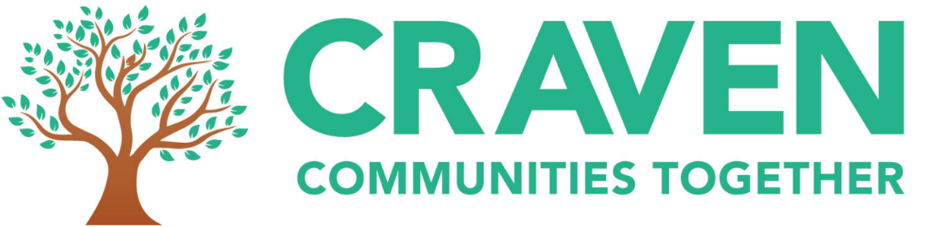
Craven Communities Together: Timely Access to Services & Support
Survey Responses
- 543 responses so far – low on the Grassington area, men and people who aren’t white
- Key issues emerging:
  - GPs – information, access, diagnosis – there were a lot of comments about GP practices and seeing GPs
  - Transport – 46% of respondents had transport as one the things that stops them using health and wellbeing services or makes it harder for them to access them
  - Increasing awareness of non NHS services and support. When we asked about waiting times for support, generally the answer from most respondents was that they hadn’t heard about the service.
- Other things mentioned:
  - Waiting times significant for some for diagnosis, scans or screening, dentists, mental health assessment and treatment, outpatient appointments, hospital treatment, operations – this is similar to national trends.
  - In terms of waiting times for emergency services, mental health services were those with the longest waiting times or where people had sought alternatives due to the long waiting times.
  - Other issues people mentioned that stopped them accessing services or made it more difficult included: inconvenient appointment times; wanting to see the same GP; wanting a face to face appointment; having to take time off work/that it can take a day to get to an appointment; no local service available.
  - 46% of respondents are willing to use technology for all services; 24% are willing to use technology to book appointments and order prescriptions. Only 10% said they aren’t willing to use technology. However, some of the comments stressed that technology should only be one option and there should still be face to face appointments.
  - 74% of respondents felt that services have got worse during the pandemic.
- In terms of demographics:
  - 71% are women
  - 26% are 25 – 49, 36% are 50 – 64, 32% are 65 – 79 and 2% are over 80
  - 91% are white
  - 76% are heterosexual
  - 19% are carers
  - 24% are disabled
  - 53% have a long term condition

