Writing for Wellbeing
Mondays 10.30am to 12.30pm
16th August to 13th September (4 weeks)

Over four sessions we will develop a toolbox of writing techniques that promote wellbeing. Through journalling, letter writing, reflective writing, biography, poetry and play we will have fun in a safe and fun supportive session. No need to read anything aloud. It can be a private process but in a shared space. Writing is like a conversation with yourself. These sessions aim to offer up a range of ways to get that conversation started.
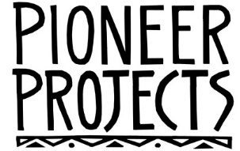
For more information or to book a place:
email office@pioneerprojects.org.uk or call 015242 62672

