

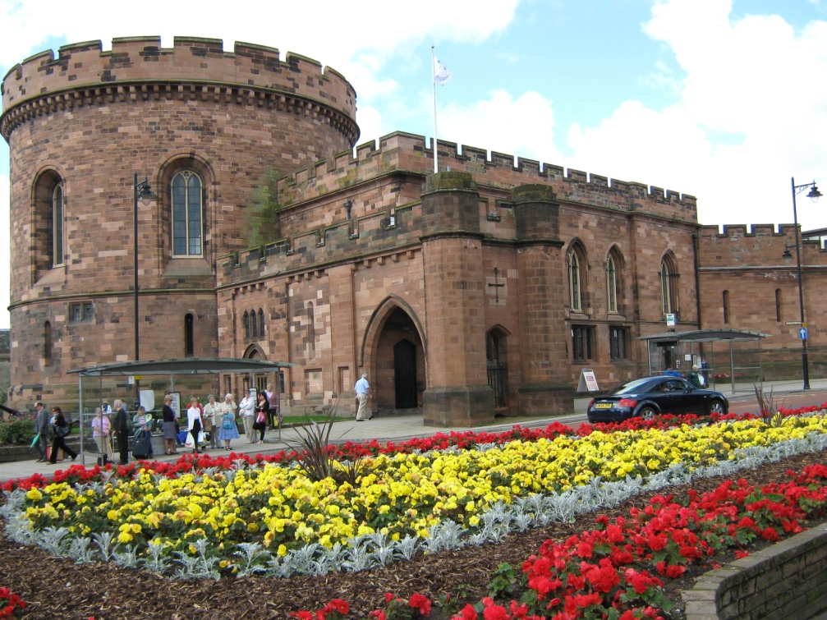 |  | MAKE THE MOST  OUT OF LIFE!
CARLISLE  Social Diary  2020 | 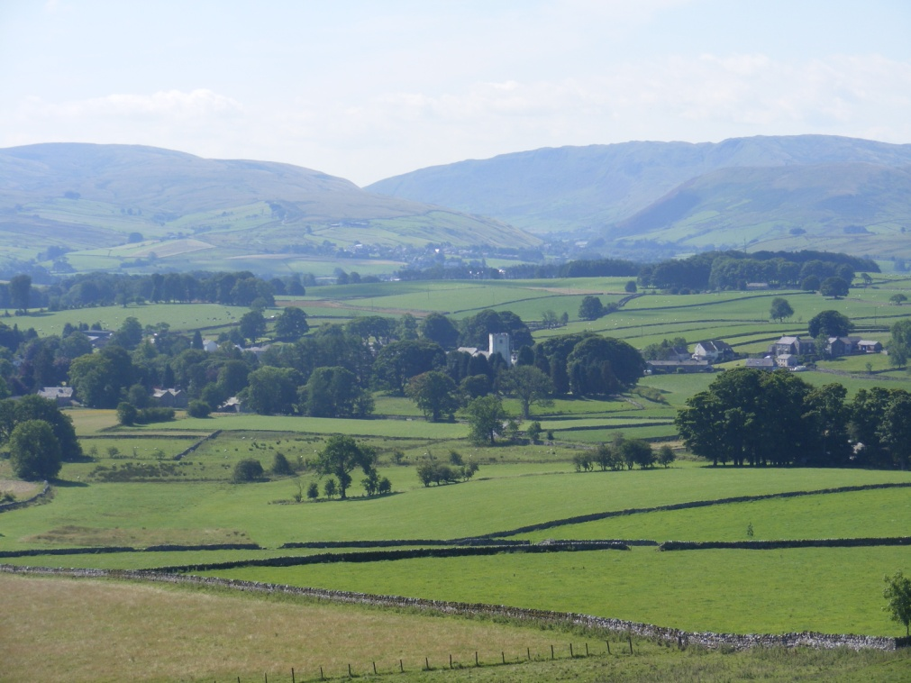

If you would like more information please contact:

Age UK Carlisle and Eden
20 Spencer Street
Carlisle
CA1 1BG
Tel: 01228 536673

Appleby
Riverside Building
Chapel Street
Appleby
CA16 6QR
Tel: 01228 536673

E-mail: admin@ageukcarlisleandeden.org.uk

www.ageuk.org.uk/carlisleandeden

A larger print version of this booklet
is available on request

Please note there may be a charge for many of the activities
in this diary. For further information contact the
organiser directly on the numbers listed.

AGE UK DAY CARE GROUPS & LUNCH CLUBS
Please contact Age UK to join any of
These clubs before attending

CLUB | VENUE | DETAILS | CONTACT
Four Seasons Day Group | St Cuthberts Court | Wednesday  10.30am-3pm | 01228 536673
Gateway Lunch Club | Morton Manor Community Centre | Thursdays  11.15am-2pm | 01228 536673
Memories in Motion | St Cuthberts Court | Mondays  10.30am-3pm | 01228 536673

ART

CLUB | VENUE | DETAILS | CONTACT
Art  Group | Currock  Community Centre | Wednesdays  1pm-3pm | 01228 591868
Arts and Crafts | Brampton Community Centre  The Hut | Mondays  7pm-9pm | 016977 45023
Creative Arts and Conversation for Older People | Prism Arts  Carlisle Business Centre | Tuesdays  10am-12pm  1pm-3pm | 01228 888630  (Booking essential)
Relaxed Art Class | Longtown Community Centre | Wednesdays  2pm-4.30pm | 01228 791876

BINGO

CLUB | VENUE | DETAILS | CONTACT
Bingo | Longtown Community Centre | Tuesdays  7.15pm-8.45pm | 01228  791876
Bingo | Morton Community Centre | Mondays  7.30pm-9.30pm | 01228  531105
Tyne Street Pensioners Club | Greystone Community  Centre | Thursdays  1pm-4pm | 01228  558602

BOWLING

Club | Venue | Details | Contact
Beginners  Short Mat Bowling | Morton Community Centre | Mondays  2pm-4pm | 01228  531105
Bowling Club | Morton Community Centre | Sundays  7.30pm-9.30pm | 01228 531105
Short Mat Bowling | Longtown Community Centre | Mondays  1pm-3.00pm  Tuesdays  1pm-3pm | 01228  791876
Short Mat Bowling Club | Yewdale Community Centre | Tuesdays  1.30pm-3.30pm  Thursdays  8pm-9.30pm | 01228  591270

BRIDGE

Club | Venue | Details | Contact
Bridge Club | Brampton Community Centre | Mondays  7pm-10.30pm | 01228 561189
Eden Bridge Club  (Beginners) | Town Dyke Orchard, Viaduct Estate, Carlisle | Mondays  7.00pm | Beginners:  Geoff 542070  Improvers  John 710772
Eden Bridge Club | Town Dyke Orchard, Viaduct Estate, Carlisle | Tuesdays 7.15pm, Wednesdays 7pm  Thursdays 7.15pm  Saturdays 6.45pm | 01228 534650

COMPUTER

CLUB | VENUE | DETAILS | CONTACT
Computer Courses all levels | Kingmoor Community and Business Centre,  Liddle Close, Carlisle | Call in or phone for friendly advice | 01228 598484
Computer courses all levels, drop in sessions | Upperby Community Development Centre, Uldale Rd, Upperby | Call or phone for further details | 01228 815461
Computer Courses all levels, plus weekly drop-in | Pennine Way Community Development Centre  Silverdale Rd  Harraby | Please call or contact our friendly staff for information | 01228 598978

DANCING

CLUB | VENUE | DETAILS | CONTACT
Social Sequence  Dancing | Currock Community Centre | Tuesdays  8pm-10pm | 01228 591868

EXERCISE

CLUB | VENUE | DETAILS | CONTACT
Fell Walking | Meet Brampton Community Centre | Wednesdays 8.30am | 016977 45023
Happy Wanderers | Brampton Community Centre | Tuesdays  9.30-12noon | 016977 45023
Nifty Fifty  Tennis | Chatsworth Tennis Club  St Aidan’s Road | Wednesdays  1.00pm-3.00pm  Open to non members | 01228 514187
Park Walks | Morton Community Centre | Mondays  2.30pm  30 minute duration | Emma Dixon  01228 817370
Pilates | Brampton Community Centre | Fridays  9.50am -10.15am | 07702 735070
T’ai Chi | Denton Holme Community Centre | Mondays 10-11am | 01228 710898
The Wellbeing Group – For over 50s recovering from some form of disability | Church of Scotland, Chapel Street  Carlisle | Each Wednesday 11am  £5 per session | Geoff Haugh 07484 636052  Celia Jackson 07594 711332  Val Walker  07786 531721

GENERAL

CLUB | VENUE | DETAILS | CONTACT
Cinema Night including refreshments | Burnside Court  Rosebery Rd | Thursdays  4pm-7pm | 01228  542291
Watchtree Nature Reserve | Wiggonby  Great Orton  Nr Carlisle | Open daily during summer. Organised walks  various times | 01228 712539
Whist Drive | Longtown  Community Centre | 3rd Saturday  in month  7.00pm | 01228 791876
Women’s Institute | Brampton WI  Moot Hall | 3rd Wednesday of month  7.30pm
 | Cumdivock WI  WI Hall | 1st Wednesday of month  7.30pm
 | Longtown WI  Longtown Memorial Community Centre | 2nd Monday of month  7.30pm

LUNCH CLUBS (OTHER)

CLUB | VENUE | DETAILS | CONTACT
Club 60+ Lunch | Crown Hotel Wetheral | Every Thursday  12 noon – 2pm | 01228 561888
Coffee Meeting | Bobbin Café at Linton Tweeds. | 1st Saturday of each month. 14:00- 15:30 | Sheena Gray  Tel: 07765 126236
Drop-in lunches | Morton Community Centre | Wednesdays  12pm-1pm | 01228  531105
Lunch Club | Currock Community Centre, Lediard Avenue, Carlisle | Thursday 12pm – 1.30pm | 01228 591868
Lunch Club | Country Kitchen, Dalston | 2nd Tuesday of the month  12 noon | Joyce Dayson  01228 711431
Luncheon Club | Botcherby Community Centre | Fridays  11.30am-12.45pm | 01228  596992

SEWING/KNITTING/CRAFTS

CLUB | VENUE | DETAILS | CONTACT
Embroiderers Guild | St Herbert Church Hall  Blackwell Road | Last Saturday in month  10.30am-4pm  Except Aug and Dec | 01228 562988
Knit, Stitch and Natter | Brampton Community Centre  Union Lane  Brampton | Wednesdays  9.30-12noon | 016977  45023

SOCIAL

CLUB | VENUE | DETAILS | CONTACT
Houghton Evergreens | Houghton Village Hall | Thursdays  2pm-4pm | Mr Webber  01228 594707
Towns women’s Guild | Currock House  Community Centre | Mondays  8.30pm-10pm | 01228 591868
Tyne St  Over 60’s | Grey Stone Community Centre | Thursday  1pm-4pm | 01228 558 602
Amy’s Care.  Social activity/ day trips for older people, particularly those living with dementia | Meet at Burnside Court, Rosebery Road, Stanwix ( transport available) | Every Monday 10.30am – 4pm | Fraser Dooley 016973 71973 www.amys-care.co.uk
Amy’s Care.  Social activity/ day trips for older people and particularly those living with dementia | Meet at Heysham Gardens, Brookside, Carlisle ( transport available) | Every Tuesday 10.30am – 4pm | Fraser Dooley 016973 71973 www.amys-care.co.uk

SUPPORT AND HEALTH RELATED GROUPS

Group | Venue | Details | Contact
Alzheimer’s Society | The New Waterton Hall  Warwick Square  Carlisle | Dementia Cafe  Second Wednesday of the month  10am-12pm | 01228 819299
 | The New Waterton Hall  Warwick Square  Carlisle | Singing for the Brain  Thursday  1.30pm-3pm | 01228 819299
 | Walking Group | Easy walks followed by lunch  Every six weeks  Call for details | 01228 819299
Blood Buddies  For those affected by leukaemia, lymphoma, myeloma or associated conditions. | Bidders Bar at  The Auctioneer, Rosehill, Carlisle at 7.00pm | 2nd Monday  of month | Angela Docherty secretary to  Dr O’Brien on  01228 814511
Breath of Life Carlisle – Support Group for those who suffer from Respiratory diease | Church of Scotland, Chapel Street, Carlisle | Every Tuesday 1.30pm – 2.45pm | Carole 01228 711456
Cancer Information and Support Centre | Cumberland Infirmary, Newtown Road, Carlisle | Mon – Friday  10am-4pm | 01228 814283
Carlisle Carers | Fusehill Street, Carlisle | Carer Support | 01228 542156
Carlisle ME /CFS Support Group | Lintons | 2nd Saturday  in month | 01228 562988
Carlisle Society for the Blind | 9 Brunswick Street, Carlisle | Macular Disease Society 2nd Thursday in month  11am–1pm | 01228 593104
Colostomy Association | 24 hour helpline | 0800 3284257 | e-mail: cass@colostomy  association.org.uk
Macmillan Information and Support Services | Cumberland Infirmary, Newtown Road, Carlisle | Monday-Friday  10am-4pm | Hilary Kendal  01228 814283
North Cumbria Prostate Cancer Support Group | Morton Manor | 1st Tuesday  in month  7pm | Jim Allan 01228 539510  email: james101@talktalk.net
Memory Matters Carers Support Group | Carlisle Library | Every Monday  (except bank holidays) | Memory Matters Team  01228 602100

USEFUL INFORMATION

VENUE | WHAT’S ON | DETAILS | CONTACT
Carlisle Castle | Guided Tours and Special Events | April-September  10am-6pm  October  10am-5pm | 01228 591922
Carlisle Cathedral | Services  Restaurant and Gift Shop |  | 01228 548151
Vue  Cinemas Botchergate | Senior Vue film club | Late Wed morning film including tea/coffee | 0345 308 4620
Tullie House Museum and Art Gallery | Exhibitions, Workshops Talks Performances Films | Various dates and times | 01228 618718
The Sands Carlisle | Sport, Leisure and events | Various dates and times | 01228 633766
Carlisle Library  The Lanes Carlisle | Community Information  Reference Internet  Activities, talks | To check times contact library | 01228 227312

We try our best to keep this diary up to date, but cannot be responsible for any changes to activities or groups run by other organisations.
If you run a club or group we would appreciate being told of any changes to information shown in this diary.

We would also love to hear from new clubs and groups who would like to be included.

