Raising essential funds for your local sight loss charity, supporting people living with sight loss across the South Lakes area.

AUTUMN CEILIDH & Light Supper
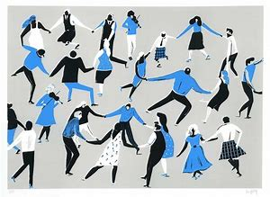

Date: Sat 9th November 2019
Time: 7.30pm - 10.30pm
Venue: Castle Street Community Centre,
Castle Street, Kendal, LA9 7AD

Tickets: £10.00pp - Live Music by ‘Jackodandy’ & light supper. Soft drinks available or bring own bottle
Tickets Available:
Sight Advice South Lakes 116 Highgate Kendal. LA9 4HE. Tel 01539 769055

